|  |  |  |  |
| --- | --- | --- | --- |
| #1-12 | |  | |
|  |  | | 1. ______________ 2. ______________ 3. ______________ 4. ______________ 5. ______________ 6. ______________ 7. ______________ 8. ______________ 9. ______________ 10. ______________ 11. ______________ 12. ______________ |
| 13. |  | | |
| 14. | Using the Venn diagram to the right:  a. How many people were surveyed?  b. How many people like Rock and Rap?  c. How many people like Rock or Country? | | |
| 15. | The Venn diagram shows the different place students had been in  the last year: Water Park (W), Fair (F) and Zoo (Z).  a. How many students went to the water park?  b. How many students went to the fair and the zoo? | | |

ANSWERS

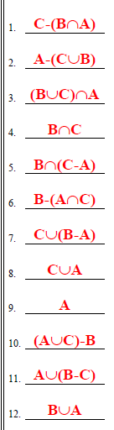

#13



#14 a.  b.  c. 

#15 a.  b. 