Coordinate Geometry Review Name: _________________________ Period:____

**MIDPOINT**

1. Find the midpoint of the segment with endpoints

a) (6,-7) and (3,-5) b) (12,5) and (-9,-1).

3. Find x and y if

a) the midpoint = (3, -4) with endpoints are (x,y) and (9,14) b) the midpoint = (7, 10) with endpoints are (x,y) and (-5,6

3. Find the two coordinates that divide the segment into thirds.

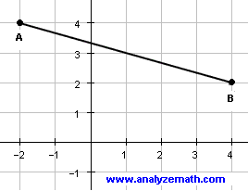

**SLOPE, EQUATIONS, PARALLEL/ PERPENDICULAR LINES**

Determine the slope of the line that contains the given points.

4.  5. 

6.  7. 

Determine whether and are parallel, perpendicular, or neither.

8.  9. 

10.  11. 

Write an equation for each line described:

12.  13.  14. 

15. Write an equation for the line in slope-intercept form .

a c. A line parallel to  through (5,4) b. A line perpendicular to through (-6,3)

**SOLVING SYSTEMS – choose one to do with elimination, one to do with graphing and one to do with substitution**

16.  17.  18. 

**DISTANCE FORMULA**

Find the distance between the points.

19.  20.  21. 

**EQUATION OF A CIRCLE**

Write the equation of each circle.

22. Center at the origin, radius 6 23. Center at (4, 3), radius 9 23. Center at (4, 3), radius 9

25. C(7,1), diameter 24 26. C(-4, -1), passes through (-2, 3) 27. C(5,-2), passes through (4,0)

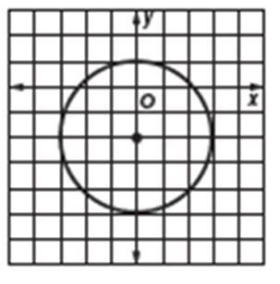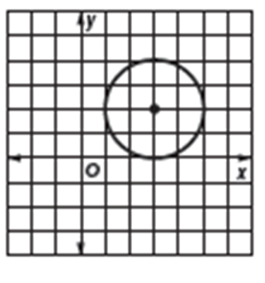28. 29.

30. Find the center, the radius, and graph the circle.

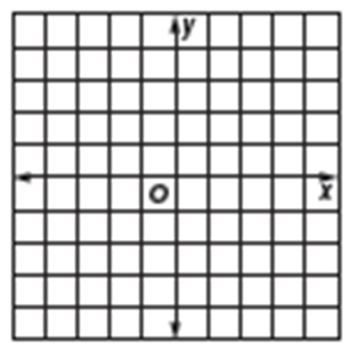a.  b. 



**COORDINATE PROOFS**

Triangles:

31. Find the measures of the sides of  and classify each triangle by its sides.

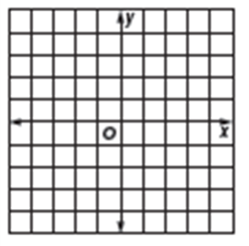a. K (-3, 2), P (2, 1), L (-2, -3) b. K (5, -3), P (3, 4), L (-1, 1) c. K (-2, -6), P (-4, 0), L (3, -1)

MIDSEGMENT

32.  has vertices D(-3, 0), E (7, -2), F (1, -4). Is  a midsegment given points G(2, -1) and H(-1, -3)?

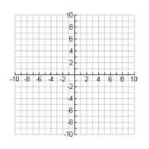

Quadrilaterals

33. Prove whether quadrilateral PQSY is a parallelogram. Show all work.





34. Prove whether quadrilateral JKLM is a rectangle. Justify your answer by showing all work.



Prove whether QRST is a rhombus, rectangle, or square.

35. 36.