Pre Calc 6-2 Word Problem Practice WS
Answers:

1. What is each student’s final grade?

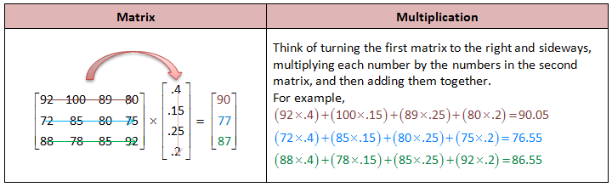
Alexandra has a 90, Megan has a 77, and Brittney has an 87

2.
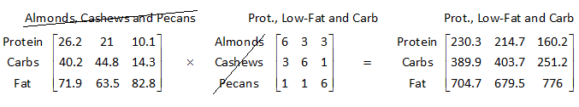

The entire matrix is the answer.
3.
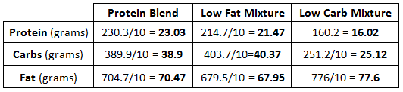
4. This one’s a little trickier since it looks like we have two 3 x 2 matrices (tables), but we only want to end up with three answers: the total score for each of the girls.
If we were to do the matrix multiplication using the two tables above, we would get:
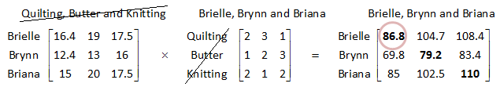
So Brielle- 86.8, Brynn- 79.2, and Briana-110
5. Store A, $4600 | 6. Holly- system B, Joelle- system B, Luisa- system A
7. the 10-ton truck takes 7 trips and the 12-ton truck takes 13 trips

