11-1, 11-2 Stats and Probability Distribution Practice WS

1. By hand, calculate the standard deviation for this sample data: 9, 6, 2, 5 and 10. Show all work.

3. A histogram for the number of patients treated at 50 U.S. cancer centers in one year is shown.
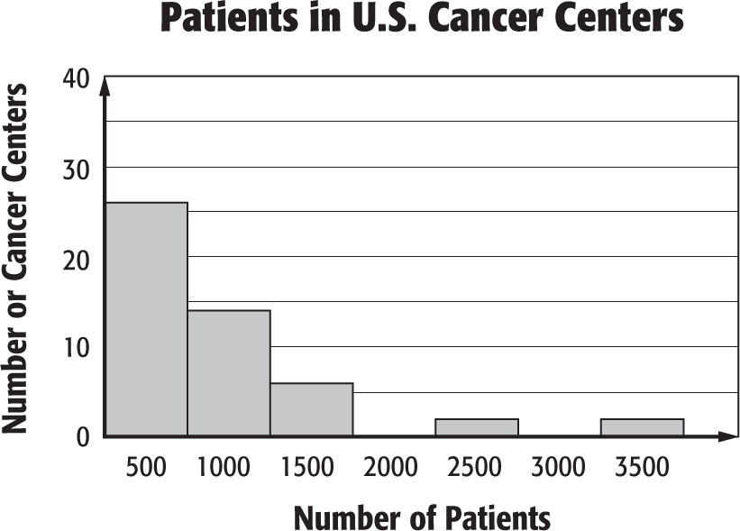

a. Describe the shape of the histogram. What statistics (5 number summary, mean and standard deviation) would you
use to summarize the center and spread of the data?

b. Sketch the general shape of a box plot that would represent the histogram.

4. Twenty members of a golf team each hit a golf ball as far as they could. The table shows the distance each team member drove his or her ball.

Distance Traveled (yards)
185 | 185 | 190 | 190 | 190 | 200 | 200 | 200 | 200 | 200
210 | 210 | 210 | 210 | 210 | 215 | 215 | 215 | 270 | 280

a. Enter the data on your graphing calculator and construct a histogram. (Use a bin width of 10 yds) Make a sketch of
the histogram and describe its’ shape. (Symmetrical, positively skewed, negatively skewed, bi-modal)

b. Summarize the center and spread of the data using either the mean and standard deviation or the five-number summary. Your choice should be justified by your description above.

5. A shoe store employee designs a display by placing shoe boxes in ten stacks. The number of boxes in each stack are
5, 7, 9, 11, 13, 10, 9, 8, 7, and 5.

a. Use your graphing calculator to construct a box plot for this data. Make a rough sketch of the box plot on your paper.

b. Summarize the center and spread of the data using either the mean and standard deviation or the five-number summary. Justify your choice.

Classify each random variable X as discrete or continuous. Justify your answer
6. X represents the time it takes a randomly selected classroom to reach 68°F from 60°F.

7. X represents the number of photographs taken by a photographer at a randomly selected wedding.

8. A resort is planning a bicycle race. The cost of sponsoring the race is $8000. The resort expects to make $15,000 on the event. There is a 30% chance of a hurricane arriving the day of the race. If this happens, the race will be cancelled and will not be rescheduled. What is the resort’s expected profit?
11-1, 11-2 Stats and Probability Distribution Practice WS

1. By hand, calculate the standard deviation for this sample data: 9, 6, 2, 5 and 10. Show all work.

3. A histogram for the number of patients treated at 50 U.S. cancer centers in one year is shown.

a. Describe the shape of the histogram. What statistics (5 number summary, mean and standard deviation) would you
use to summarize the center and spread of the data?

b. Sketch the general shape of a box plot that would represent the histogram.

4. Twenty members of a golf team each hit a golf ball as far as they could. The table shows the distance each team member drove his or her ball.

Distance Traveled (yards)
185 | 185 | 190 | 190 | 190 | 200 | 200 | 200 | 200 | 200
210 | 210 | 210 | 210 | 210 | 215 | 215 | 215 | 270 | 280

a. Enter the data on your graphing calculator and construct a histogram. (Use a bin width of 10 yds) Make a sketch of
the histogram and describe its’ shape. (Symmetrical, positively skewed, negatively skewed, bi-modal)

b. Summarize the center and spread of the data using either the mean and standard deviation or the five-number summary. Your choice should be justified by your description above.

5. A shoe store employee designs a display by placing shoe boxes in ten stacks. The number of boxes in each stack are
5, 7, 9, 11, 13, 10, 9, 8, 7, and 5.

a. Use your graphing calculator to construct a box plot for this data. Make a rough sketch of the box plot on your paper.

b. Summarize the center and spread of the data using either the mean and standard deviation or the five-number summary. Justify your choice.

Classify each random variable X as discrete or continuous. Justify your answer
6. X represents the time it takes a randomly selected classroom to reach 68°F from 60°F.

7. X represents the number of photographs taken by a photographer at a randomly selected wedding.

8. A resort is planning a bicycle race. The cost of sponsoring the race is $8000. The resort expects to make $15,000 on the event. There is a 30% chance of a hurricane arriving the day of the race. If this happens, the race will be cancelled and will not be rescheduled. What is the resort’s expected profit?
9. An insurance company insures a painting worth $20,000 against theft for $300 per year. The company has assessed the probability of the painting being stolen in a given year as 0.002. What is the insurance company’s expected annual profit?

10. A store manager made the probability distribution shown below. It shows the probability of selling X swimsuits on a randomly selected day in June.

Swimsuits, X | 19 | 20 | 21 | 22 | 23
P(X) | 0.20 | 0.20 | 0.30 | 0.20 | 0.10

Find the mean, variance, and standard deviation of the distribution.

11. The table shows the number of cell phones owned by 100 randomly selected
Phones, X | Frequency
0 | 2
1 | 30
2 | 48
3 | 13
4 | 7
households.

a. Construct a chart and bar graph to show a probability distribution for X.
b. Find and interpret the mean in the context of the problem situation.
c. Find the variance and standard deviation.

12. The number of pairs of shoes bought by each of 100 randomly selected shoe store customers during
one week is shown in the chart.
a. Construct a probability distribution for X. (chart and bar graph)
Shoes, X | Frequency
0 | 15
1 | 40
2 | 25
3 | 20
b. Find and interpret the mean in the context of the problem situation.

c. Find the variance and standard deviation.

13. You go to a local carnival and find a new game of chance. It costs $5.00 to play and promises a prize every time. This is a ring toss game where there are 100 bottles in front of you. If it lands on one of the 5 bottles that are painted green you win the grand prize valued at $20. If it lands on one of the 15 red bottles you win a prize valued at $10. If it lands on one of the 20 blue bottles you win a prize valued at $2.50. If it lands on any of the other bottles you get a prize valued at $.25. You get one ring but you continue to throw it until it lands on a prize.
What is the expected value of this game if you play it one time?

9. An insurance company insures a painting worth $20,000 against theft for $300 per year. The company has assessed the probability of the painting being stolen in a given year as 0.002. What is the insurance company’s expected annual profit?

10. A store manager made the probability distribution shown below. It shows the probability of selling X swimsuits on a randomly selected day in June.

Swimsuits, X | 19 | 20 | 21 | 22 | 23
P(X) | 0.20 | 0.20 | 0.30 | 0.20 | 0.10

Find the mean, variance, and standard deviation of the distribution.

11. The table shows the number of cell phones owned by 100 randomly selected
Phones, X | Frequency
0 | 2
1 | 30
2 | 48
3 | 13
4 | 7
households.

a. Construct a chart and bar graph to show a probability distribution for X.
b. Find and interpret the mean in the context of the problem situation.
c. Find the variance and standard deviation.

12. The number of pairs of shoes bought by each of 100 randomly selected shoe store customers during
one week is shown in the chart.
a. Construct a probability distribution for X. (chart and bar graph)
Shoes, X | Frequency
0 | 15
1 | 40
2 | 25
3 | 20
b. Find and interpret the mean in the context of the problem situation.

c. Find the variance and standard deviation.

13. You go to a local carnival and find a new game of chance. It costs $5.00 to play and promises a prize every time. This is a ring toss game where there are 100 bottles in front of you. If it lands on one of the 5 bottles that are painted green you win the grand prize valued at $20. If it lands on one of the 15 red bottles you win a prize valued at $10. If it lands on one of the 20 blue bottles you win a prize valued at $2.50. If it lands on any of the other bottles you get a prize valued at $.25. You get one ring but you continue to throw it until it lands on a prize.
What is the expected value of this game if you play it one time?

