 | Find the AREA of each Trapezoid. |  | Write the Trapezoid Formula here | A =
1. | 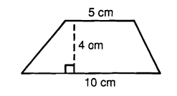 | 2. | 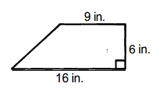 | 3. | 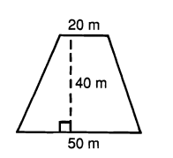
 | b₁=_________  b₂=_________  h =_________  Area = _______________ |  | b₁=_________  b₂=_________  h =_________  Area = _______________ |  | b₁=_________  b₂=_________  h =_________  Area = _______________
4. | 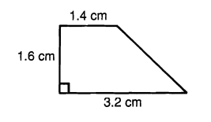 | 5. | 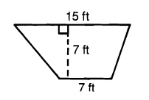 | 6. | 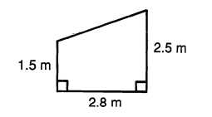
 | b₁=_________  b₂=_________  h =_________  Area = _______________ |  | b₁=_________  b₂=_________  h =_________  Area = _______________ |  | b₁=_________  b₂=_________  h =_________  Area = _______________
 | Find the AREA of each Regular Polygon. |  | Write the Regular Polygon Area Formula here | A =
1. |  | 2. |  | 3.
 | A ≈_________  s = 4 cm  a = 5.5 cm |  | A ≈_________  s = 18 in  a = 15.6 in |  | A ≈_________  s = 24  a =24.9
4. | Regular Pentagon:  a= 3 cm  s ≈ 4.4 cm  Area ≈_________ | 5. | Regular nonagon:  a = 9.6  Area ≈ 302.4 cm²  Perimeter =_________ | 6. | Regulan n-gon:  a = 12 cm.  Perimeter = 81.6 cm  Area ≈ ____________  n = __________

